**LOCAL 2020-05 Union Membership Meeting**



# Table of Contents

Table of Contents 1

Executive Committee 2

Members - Present 2

Guest 2

Approval of the Agenda 2

Approval of the previous Minutes 2

New Business / Open for Discussion 2

Member Questions 3

Next Month Meetings 3

**Scheduled Meeting**

Date: Jan 31, 2017

Time: 6:00 P.M. – 7:20 P.M.

Room: Leo Gerard Hall

# Executive Committee

Sherri Hawkes – Unit President

Peter Larabie – Unit Safety Representative

Gilles Labelle - Unit Chief Steward Mines

Bill Chandler – Unit Chief Steward Surface Plants

Jennifer Pattison – Unit Recording Secretary

Bob Gagnon – Financial Secretary / Units Local 2020 Executive Board Member

# Members - Present

As per sign in book

# Guest

None

# Approval of the Agenda

No Agenda provided

# Approval of the previous Minutes

Approved

# New Business / Open for Discussion

During negotiations, the Bargaining committee will be communicating updates via text. Please follow these steps;

1. Text 32323
2. Message: 2020
3. Enter your Name
4. Enter your personal email address (not vale )
5. Enter Postal Code

Introduction – New Chief Steward of Surface

As per email January 12, 2017, Bill Chandlier will be replacing Mona Conley.

Temp Positions:

We have three Union employees that have moved to NUS. These employees do not pay union dues therefore are not protected under the current CBA. We have allowed Union members to move to temp positions, for 1 year, as part of career development. However, the company has asked for an extension on these contracts. Sherri has replied to the company and agrees to keep them in these NUS positions until March 1, 2017 and no later. Email was sent to the company January 26, 2017. We wait for their response. If a response is not received by the company, the Union will follow the grievance procedure.

President’s Report:

1. Nickel Chain (discussed in the first part of this meeting)
2. Who is bargaining?
   1. L2020 – 2017
   2. L9508 Voiseys – 2018
   3. L6166 Thompson – 2019
   4. L6500/6200 Port Colborne – 2020
3. Protection Letter – for members who are eligible to currently retire. Made a request to the company to allow this group to have an opportunity to retire with current benefits and be allowed to retire right after negotiations without being forced into Flex retirees to remain in current benefits just like the NUS.

Voting to take place for 2017 Contract Negotiations

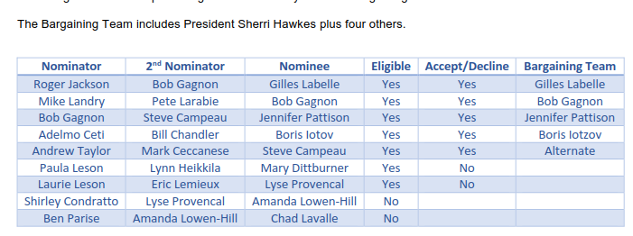

# Member Questions

Q. Is flex on the table?

A. We don’t know or won’t know until we go into negotiations. No details can be offered at this time

# Next Month Meetings

DATE OF NEXT MEETING: Scheduled meeting Feb 28, 2017. Meeting date may change due to contract negotiations